Park Brake Warning Chime – CGEA1.3

Functional Description

The purpose of the Park Brake Warning Chime feature is to inform the driver that the park brake is engaged.

The Park Brake Warning Chime feature correlates the operational mode, and the Park_Brake_Chime_Rqst Signal, to generate a Park_Brake_Chime_Status_Flag, which will be used by the chime arbitrator.

Interfaces

Interface Context Diagram (I/O Block Diagram)

Figure 1. Park Brake Warning Chime Context Diagram

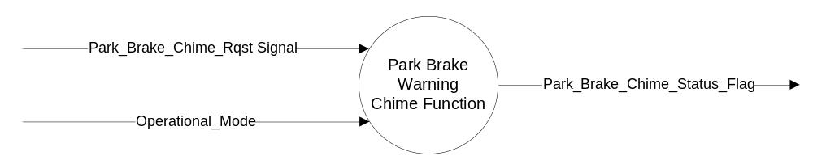

Inputs
- INTERNAL:
  - Operational_Mode

- MUX message on the CAN Bus

- Park_Brake_Chime_Rqst Signal
Signal Name | Size (bits) | Detail | Units | Res. | Offset | State Encoded | Min | Max
Park_Brake_Chime_Rqst | 1 |  |  | 1 | 0 |  | 0 (0x0) | 1 (0x1)
 |  | Off |  |  |  | 0x0
 |  | On |  |  |  | 0x1

Outputs
- Internal flag to Chime Arbitrator : Park_Brake_Chime_Status_Flag

Function/Performance

Operational Modes

Mode | Differentiating Vehicle Conditions
Sleep Mode | OFF
Limited Mode | OFF
Normal Mode | OFF / ON
Crank Mode | OFF

Voltage Levels

Refer to Cluster Features Table located in Operational Modes and Voltage Range Strategies section in this SPSS.

Human-Machine Interface

Visual

None

Audio

Refer to Audio Section in Chimes & Chime Arbitrator SPSS Section

Switch Control Logic

None

System Accuracy

- The state of this chime flag shall change within 100 msec of a state change as indicated in the state matrix found in section 1.3.5.1 of this document
- Refer to System Accuracy in Chimes & Chime Arbitrator SPSS Section

Operation: Performance and Functional

Subsystem Algorithm Flowchart / State Diagram

Operational_Mode | Last Value Received  Park_Brake_Chime_Rqst Signal | Park_Brake_Chime_  Status_Flag
NORMAL | ON | True (0x1)
NORMAL | Missing as per 1.4.1 | False (0x0)
All Other Cases |  | False (0x0)

Operation Description (supports algorithm flowchart /state diagram)

- The Park_Brake_Chime_Status_Flag is set, maintained and cleared by the BCM
- Park Brake Switch is sensed by BCM and used by BCM to determine the state of Park_Brake_Chime_Rqst signal, which it transmits to the IC

Function Safety Classification (EMC)

Class B

Memory Storage

Parameter Name | Description | Value at Battery connect | Value at  Module Wake-up
Park_Brake_Chime_Status_Flag | State indicator for the chime | FALSE | Do Not Init
Park_Brake_Chime_Rqst signal | CAN Signal sent from the BCM | Off (0x0) | Do Not Init
Operational_Mode | 4 State indicator for cluster operational mode | Limited | Limited or Normal or Crank
Note: "Do not init" = last known value

Prove Out

No

Reconfigurable Teltale

No

Message Center Msg

No

Error Handling

Missing Message Strategy

The signals will be declared missing as per the Diagnostics section of this SPSS.

DTCs states and history will be determined as per the Diagnostics section of this SPSS.

Diagnostics

Self Test

None

Engineering Test Mode

While in ETM the chime will behave as the State Matrix, however the chime cannot be triggered through ETM directly. The last chime played is one of the ETM displays. Reference section “Dealer / Engineering Test Mode (ETM)”

Part II Performance

Supported Diagnostic Trouble Codes (DTCs)

DTC | Description
C14000 | Lost Communication with Body Control Module (BCM)

Reference Specification

Chime Arbitrator EF-0033
Park Brake Warning Chime EF-0153

Revision History

SPSS Module Revision History

Revision Level | Name | Change Description | Date
1.0 | V. Patel | Updated for CGEA 1.3 based on CGEA STSS v1.0  Section 1.2.2 – Deleted table referencing the HS-CAN message that contains the input signal. Deleted “ID” and “POS” columns from table 1.0  Section 1.4 – Rewritten. Removed references of specific missing message flags.  Section 1.5.3 – Deleted DTC logging criteria from the table. | 3/24/2010
1.1 | S. Watkins  M. Hakim | This revision is for cleanup and removing Diag DID 61B5 from the chime STSS.  Deleted the Diag DID and Diagnostic Session Timer throughout the document.  Section 1.3.5.1: Updated the table after removing Diag DID 61B5 and the Diag_Session_Timer.  Section 1.3.5.4: Memory Storage table:  - Corrected the font capitalization used for Park_Brake_Chime_Status_Flag  - Added Park_Brake_Chime_Rqst signal to the table.  Section 1.5.3: Updated the Lost Communication DTC fault bits to 00.  Updated document footer | 8/14/2013

